Low-temperature thermochronology
(VV Nr: 14368-01)
Short course (2KP)

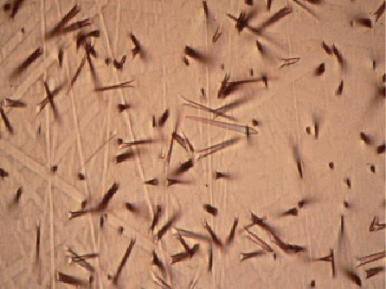

Lecturer:
PD Dr. Alexandre Kounov
e-mail: a.kounov@unibas.ch
Tel. ++41612670484
Fax. ++41612673613

Venue: Department of Environmental Sciences
Bernoullistrasse 32
Basel 4056

Schedule: Frühjahrsemester 2018
The course comprises 12 hours distributed over three to five days.
Exact dates will be fixed with the participants.

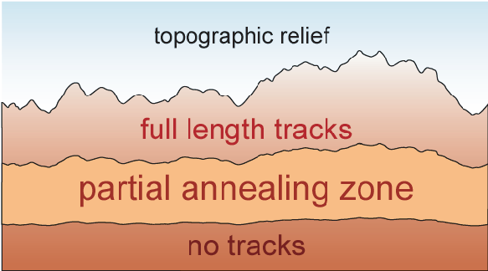

Description
Low Temperature Thermochronology is concerned with the study of the time-temperature history of the shallow levels of the Earth’s crust, where temperatures are generally between about 25ºC and 300ºC. In the last years, rapidly expanding interest in shallow-crustal and earth- and planetary-surface processes, have led to significant advances in the techniques, applications, and interpretations of thermochronometry. This course will focus attention on fission-track method and some of its main applications. The fission-track technique is a very useful tool in the analysis of tectonic evolution of orogenic belts, including exhumation, unroofing and/or cooling histories, locating, and determining amount of vertical movement of major faults, and provenance studies of sedimentary sequences. Short Introduction will be given also in some other low-temperature techniques ((U-Th)/He dating and cosmogenic nuclides surface exposure dating).

FOR DETAILS CONTACT ALEXANDRE KOUNOV
e-mail: a.kounov@unibas.ch

